Personal Project Portfolio

Software Design and Development

Edward Webb

Contents

Proposal 2

Define the Problem 2

Identification of the Problem 2

Ideas 2

Requirements 2

Gantt Chart 4

Understanding the Problem 5

Storyboard 5

Context Diagram 5

Feasibility Study 6

Social and Ethical Issues 6

Malware 6

Intellectual Property 6

Quality 6

Issues 7

Ergonomics 7

Inclusivity 7

Privacy 7

Plan and Design 7

Data Flow Diagram 7

System Flowchart 8

Specifications 8

Data Dictionary 8

Algorithms 9

Test Data 12

IPO Chart 13

Window Design 13

Feedback for Projectile Motion Analyser 14

Data Structures 14

Files that are used by the program 14

Implementation 14

Tools Used 14

User Documentation 14

How to use Projectile Motion Analyser: 14

Feedback 18

Evaluation 19

Testing 19

Requirements 19

Testing on school computers and other computers 20

Maintenance 20

Social and Ethical Issues Testing 21

Authorship/Copyright 21

Reliability 21

Response to Problems 21

Malware 21

Plagiarism 21

End User Agreement 22

# Proposal

This program will take several variables relating to projectile motion eg. Initial velocity, maximum height the projectile reaches, the range of the projectile, etc. and will determine the rest of the variables and show the path of the projectile on a graph. Developing the graph will involve measuring what height the projectile is at a point of the projectile’s motion and placing a dot on the graph. The graph could have multiple dots to create a curve. Excel could also be used as an alternative in creating the graph.

Advantages: Small project, is possible in Visual Basic 6

Disadvantages: Possibly too hard to do in Visual Basic 6 in creating the graph, and will require many functions to determine the rest of the variables.

# Define the Problem

## Identification of the Problem

The problem presented is that physics students require a program that can easily solve and visualise projectile motion problems. This would include calculating the initial velocity, its maximum height, its range, its horizontal and vertical velocity at any point of time, and its time. It must be able to input different variables and output the rest of the variables. A graph which visualises the projectile’s motion is also required to allow physics students to easily solve any projectile motion problem.

## Ideas

* The program could calculate the position of the ball at a certain point in its motion and pinpoint it on the graph. After creating many points, these points can be connected, creating a curve.
* Several variables will be listed with a box allowing the user to input a number into it
* If there is not sufficient information, a prompt can appear after the user enters the information saying that there is not sufficient information.
* After some information has been inputted by the user, the rest of the boxes can be filled by calculating from the user’s information and the graph can be shown.
* Excel can be used to create the curve for the graph, as Excel has a function which allows the line of a graph to be curved.
* The data required could be entered when the program is first opened, then when all necessary data has been entered, the program can then load the graph and enter all the variables into their boxes.
* A function to calculate the velocity at any point during the projectile’s motion can be added, which can be used after the graph has been loaded.

## Requirements

1. The program is to run on Microsoft Windows machines and must fit a 1920x1080 resolution as this is the resolution that school computer displays have.
2. The program must not crash when the program is put in use
3. The program must run on a computer with 4GB RAM.
4. The program must be able to visualize the projectile motion specified by the user and output variables that can be calculated from the information inputted into the program.
5. If the program cannot calculate any information from the data given, the program will output an error displaying that the information given is not sufficient.
6. The user should be able to use the program again after the user has inputted information for a projectile motion problem without having to reopen the program.
7. The program must give an error when non-numeric characters have been entered.

## Gantt Chart

# Understanding the Problem

### Storyboard

## Context Diagram

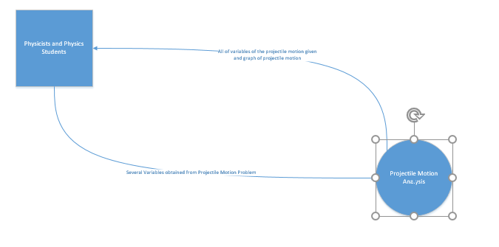

## Feasibility Study

This project is designed for physicists and physics students, and its purpose is to solve projectile motion problems. Many physics students and physicists must solve projectile motion problems, and this program can help visualise and aid with solving these problems.

The boundaries of this project include not being able to pinpoint a specific point of the projectile’s motion on the graph, as Visual Basic 6 does not have the capability to create this. The graph will also not be a smooth curve, as Visual Basic 6 does not have a proper graphing feature. However, dots can be created on the graph to attempt to create a curve, or Excel can be used to create the graph.

The benefits of creating this project include being able to solve projectile motions much more easily, and allowing physics students to check their answers easily if they need to. The program can also provide more accurate answers for projectile motion problems than what physicists can calculate by hand, and can create a visual aid for students by showing what the projectile motion should look like on a graph.

This project is possible in Visual Basic 6 as points can be placed on a drawn graph to create a curve on the graph, which visualises the projectile’s motion. There is also a limited amount of possibilities for projectile problems, and so all projectile motion problems can be solved using a program. Although Visual Basic 6 does not have a graphing function, it is still possible using Excel to create a graph.

One person is needed to create and maintain the program, and it will most likely take around 1-2 months to create. Visual Basic 6 must be used to create the program as the programmer who will develop it can program efficiently in Visual Basic 6. A computer with Windows is needed as Visual Basic 6 can only run on Windows.

If the project is not completed, the graph can be left out to allow most of the functionality of the program to operate. As the graph is the most complex part of the program and only helps achieve the purpose of the program, it can be left out if it must. This will allow students to still easily use the program, and the project to be completed in less time.

## Social and Ethical Issues

### Malware

Malware has been considered as a possible issue for the software, and so the software after completion will be scanned by antivirus software and uploaded to virustotal.com, a Google-developed website that uses many antivirus software to ensure that the software is free of malware and viruses.

### Intellectual Property

The program is owned by the Department of Education and Communities of New South Wales, as it is developed due to educational purposes. Therefore, the program’s intellectual property is protected by copyright laws as no license has been given to it.

### Quality

The program will be developed to the highest quality possible in the time frame provided. The program will be tested with school computers to ensure that it meets hardware requirements, which are that it must run on Windows with a 1920x1080 resolution. Error checking will be built into the code, and all errors that are found during the development process will be fixed and solved if time permits.

### Issues

After development, users who use the program may report any bugs and issues with the developer, and they will be fixed.

### Ergonomics

User interface elements will be used to ensure consistency with other software, which makes the program easy to use. As the program is targeted towards physicists and physics students, the program will be developed with the demographics of this target market in mind to ensure that the target market find the program easy to use. Industry standards will be used to do this. The program will also be tested by physics students to make sure the software meets the needs of physics students and physicists.

### Inclusivity

The graph in the program will follow normal science standards, with the dependent variable on the y axis and the independent variable on the x axis. All units used for variables entered and outputted will follow SI units as well to give physics students units they expect. The program will have no cost, therefore economic issues will not be considered. No offensive language will be used in the program, and a variety of testers will be used including people from both genders to address the possible inclusivity issue of gender. To address disability issues, shortcuts like TAB and ENTER can be used to operate the program as well.

### Privacy

To address a possible privacy issue, no information will be kept in a database, and the program will not save any information entered by the user.

## Constraints

* Visual Basic 6 – As this is a very old program, many bugs have been found in Visual Basic 6 which is no longer supported by Microsoft. Some features which are found in modern programming languages are also not present in Visual Basic 6, such as resizing on different resolutions. This can be a constraint when constructing the program.
* School computers - Do not support all programs, and are restricted to a 1920x1080 resolution. They also have limited performance, which may limit the construction of the program.
* Time limits – Only 6 months is given to make the program. Combined with other subjects and exams that are required, there is very limited time to construct the program.
* Amount of people working on the program – As one person is working on the program, this limits the amount of work that is possible.

# Plan and Design

## Data Flow Diagram

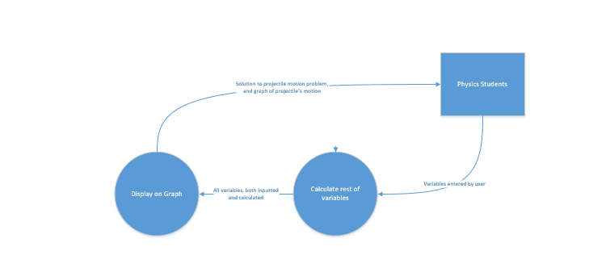

## System Flowchart

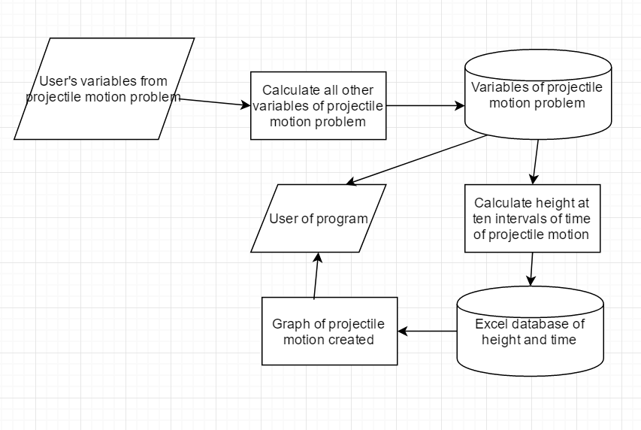

## Specifications

* Windows XP or later
* 1GB RAM or more
* 1920X1080 resolution
* Any processor will run

## Data Dictionary

|  |  |
| --- | --- |
| Variable Name | Description |
| time | The amount of time the projectile travelled before landing. |
| initVelo | The projectile’s initial velocity. |
| angle | The angle the projectile was launched from the horizontal. |
| xVelocity | The x (horizontal) component of the projectile’s initial velocity. |
| yVelocity | The y (vertical) component of the projectile’s initial velocity. |
| timeSpecific | The time the projectile took from launch to reach maximum height. |
| timeSpecific2 | The time the projectile took to land from maximum height. |
| maxHeight | The projectile’s maximum height it reached. |
| range | The horizontal distance the projectile travelled from its launch to its landing point. |
| divisor | A temporary variable used to find the angle of the projectile for the 2nd Algorithm. |
| height | The projectile’s initial height from the ground. (Always given by the user) |
| heightEnd | The projectile’s landing height from the ground. (Always given by the user) |
| heightDiff | The difference in height between the landing height and the initial height (heightEnd – height = heightDiff) |
| angleR | The angle from the horizontal the projectile was launched at converted to radians. |
| isNumeric | Boolean used to tell an if statement whether the input is numeric or not (for error checking) |
| xlApp | Variable used to contain the Excel application instance |
| xlWkb | Variable used to contain the Excel workbook instance |
| xlSht | Variable used to contain a specific sheet instance within the Excel workbook |
| timeInterval | Total time of projectile divided by 10. Used to plot points on the graph. |
| Times | Array used to contain the time part of each plot point on the graph |
| Heights | Array used to contain the height part of each plot point on the graph |
| I | Variable used for incrementing in for loops |

## Algorithms

Algorithm 1: Given Initial Velocity and Angle (Basic algorithm of the 5 algorithms that will be used in the program. All algorithms that calculate the variables are based off this one)

BEGIN

angleRadians = (angle / 180) * 3.14 // Convert angle into radians

xInitialVelocity = initialVelocity * Math.Cos(angleRadians)

yInitialVelocity = initialVelocity * Math.Sin(angleRadians)

maxHeight = (yInitialVelocity^2 / (2 * 9.8)) + height // v^2 = u^2 + 2as (projectile motion equation)

timeTillMaxHeight = yInitialVelocity / accel // v = u + at

timeAfterMaxHeight = sqrt(maximumHeight / (0.5 * 9.8)) // s = ut + 0.5at^2

range = xInitialVelocity * time

Output(time, range, initialVelocity, xInitialVelocity, yInitialVelocity, timeTillMaxHeight, angle, maxHeight) // Output these variables to the user

excelGraph(time, yInitialVelocity, height) // Graph function needs variables

END

Algorithm 2: Given initial velocity and time (2nd algorithm of the 5 algorithms that will be used in the program. This algorithm is based off Algorithm 1, but some equations have been rearranged and modified)

BEGIN

yInitialVelocity = (heightDiff – (0.5 * accel * time^2))/time // Rearrange the projectile motion equation s = ut + 0.5at^2 to (s – 0.5at^2)/t. Height is negative as height is below the initial velocity.

Divisor = yInitialVelocity / initVelo // inverse sine of yInitialVelocity/initVelo will find angle

Angle = Math.Asin(divisor) // Uses inverse sine function to find angle

xInitialVelocity = initVelo * Math.Cos(angle) // Uses cosine function to find xInitialVelocity

range = xInitialVelocity * time // Standard projectile motion equation

maxHeight = (yInitialVelocity^2 / (2 * accel)) + height // Same as Algorithm 1

timeTillMaxHeight = yInitialVelocity / accel

Output(time, range, initialVelocity, xInitialVelocity, yInitialVelocity, timeTillMaxHeight, angle, maxHeight) // Output variables to user

excelGraph(time, yInitialVelocity, height) // Graph function needs variables

END

Algorithm 3: Given range and time (3rd algorithm of the 5 algorithms that will be used in the program. This algorithm is similarly based off Algorithm 1, and similarly equations have been rearranged and modified)

BEGIN

yInitialVelocity = (heightDiff – (0.5 * -accel * time^2) / time // Same as Algorithm 2

xInitialVelocity = range / time // Standard projectile motion equation

angle = Math.Atan(yInitialVelocity / xInitialVelocity) // Using inverse tan function to find angle

initVelo = ((xInitialVelocity^2) + (yVelocity^2) ^ 0.5 // Using Pythagoras theorem to find initVelo

maxHeight = (yInitialVelocity^2 / (2*accel)) + height // Same as Algorithm 1

timeTillMaxHeight = yInitialVelocity / accel // Same as Algorithm 2

Output(time, range, initialVelocity, xInitialVelocity, yInitialVelocity, timeTillMaxHeight, angle, maxHeight) // Output variables to user

excelGraph(time, yInitialVelocity, height) // Graph function needs variables

END

Algorithm 4: Given range and maxHeight (4th algorithm of the 5 algorithms that will be used in the program. This algorithm is also based off Algorithm 1, and some code has been copied or modified from Algorithm 1)

BEGIN

yInitialVelocity = Math.Sqr(2 * accel * maxHeight) // v^2 = u^2 + 2as rearranged to give ‘u’. v = 0 as v is 0 at maxHeight.

timeTillMaxHeight = yInitialVelocity / accel // Same as Algorithm 2

timeAfterMaxHeight = Math.Sqr((heightDiff + maxheight) / 0.5 * accel) // s = ut + 0.5at^2 but u = 0 at maxHeight. heightDiff used to take into account heightEnd (most questions giving maxheight will set heightEnd to 0 though.)

time = timeTillMaxheight + timeAfterMaxHeight

xInitialVelocity = range / time // Same as Algorithm 2

angle = Math.Atan(yInitialVelocity / xInitialVelocity) // inverse tan function used to calculate angle

initVelo = (xInitialVelocity^2 + yInitialVelocity^2)^0.5 // Pythagoras Theorem

Output(time, range, initialVelocity, xInitialVelocity, yInitialVelocity, timeTillMaxheight, angle, maxHeight) // Output variables to user

excelGraph (time, yinitialVelocity, height) // Graph function needs variables

END

Algorithm 5: given range and angle (5th algorithm of the 5 algorithms that will be used in the program. This algorithm is the hardest to construct, and HSC questions rarely give problems that involve using this algorithm. The last time a HSC paper gave a question using this algorithm was in 2012.)

BEGIN

timeTemp = (heightDiff – ((range * Math.Sin(angle)) / Math.Cos(angle))) / (0.5 * -accel) // range = xInitialVelocity * time substituted into s = ut + 0.5at^2. This is one of the most complex calculations in the program. timeTemp is a temporary variable that will be used to calculate time. It will be put in a separate variable as putting it in the same line would make the code harder to read.

time = Math.Sqr(timeTemp)

initVelo = range / (time * Math.Cos(angle)) // time substituted into range = xInitialVelocity * time

xInitialVelocity = initVelo * Math.Cos(angle)

yInitialVelocity = initVelo * Math.Sin(angle)

maxHeight = (yVelocity^2 / (2 * accel)) + height

timeTillMaxHeight = yVelocity / accel

Output(time, range, initialVelocity, xInitialVelocity, yInitialVelocity, timeTillMaxheight, angle, maxHeight) // Output variables to user

excelGraph (time, yinitialVelocity, height) // Graph function needs variables

END

Algorithm 6: excelGraph Function used to display the graph and set plot points on it to construct a curved line on the graph.

timeInterval = time / 10 // Needed to create the graph accurately and to plot points on it

For i = 1 to 10:

Times[i – 1] = timeInterval * i

Heights[i – 1] = (yInitialVelocity * times[i – 1]) + (0.5 * -9.8 * times[i – 1]^2) // s = ut + 0.5at^2

End For

AddToExcelWorksheet(Times)

AddToExcelWorksheet(Heights)

excelChart.Type(lineChart)

excelChart.Smooth = True

excelChart.Show()

END

# Test Data

The following projectile motion problems will be used to test the program:

1. A projectile is fired at 30° to the horizontal from the top of a cliff 200 m high. Its initial speed is 49 ms-1.
2. A projectile is fired from the top of a 120m high cliff at 25 ms-1. It lands on the ground 6.4s after firing
3. A cannon is at the top of a 60 m high cliff firing at a castle on top of an adjacent cliff 110m high. The cannon and castle are 200m apart horizontally.
4. A cannon ball is fired at 50ms-1 from the top of a 200m high cliff so that maximum range is achieved.
5. A boy throws a rock at 15ms-1 from the top of a 75m high cliff. The rock lands in the water at the bottom of the cliff 4.0s later.
6. A projectile is thrown up from the top of a 60m high cliff. It rises to a maximum height of 44.1 m above the cliff top. It hits the ground 76m out from the base of the cliff.
7. A ball is thrown out from the edge of a 40m high cliff with a velocity of 35.1ms-1 at 30° to the horizontal.
8. A cannon ball is fired at 40° to the horizontal from the top of a 218.7m cliff and hits a target 300m from the base of the cliff.
9. A cannon fires from the top of a 150m high cliff at a castle 300m from the base of the cliff. The ball hits the castle 15 s later.

The program must match the following output data:

|  |  |  |  |  |  |  |  |
| --- | --- | --- | --- | --- | --- | --- | --- |
| Problem | Initial Velocity | Initial horizontal velocity | Initial vertical velocity | Range | Max Height | Time to reach max height | Time of flight |
| 1 | 49ms-1, 30 deg | 42.4 | 24.5 | 396.9 | 30.6 | 2.5 | 9.36 |
| 2 | 25 ms-1, 30.3 deg | 21.6 | 12.6 | 138 | 8.1 | 1.3 | 6.4 |
| 3 | 101 ms-1, 84.3 deg | 10 | 100.5 | 200 | 510 | 10.3 | 20 |
| 4 | 50 ms-1, 45 deg | 35.4 | 35.4 | 387.2 | 63.9 | 3.6 | 10.94 |
| 5 | 15 ms-1, 13.1 deg | 14.6 | 3.4 | 58.4 | 0.6 | 0.34 | 4.0 |
| 6 | 31 ms-1, 71.2 deg | 10 | 29.4 | 76 | 44.1 | 3.0 | 7.6 |
| 7 | 35.1 ms-1, 30 deg | 30.4 | 17.6 | 157.3 | 15.8 | 1.5 | 5.2 |
| 8 | 40 ms-1, 40 deg | 30.64 | 25.7 | 300 | 33.6 | 2.62 | 9.8 |
| 9 | 66.6 ms-1, 14.3 deg | 20 | 63.5 | 300 | 205.7 | 6.5 | 15 |

## IPO Chart

|  |  |  |
| --- | --- | --- |
| Input | Process | Output |
| Variables of projectile motion problem (eg. Time, initial velocity, range) | 1. Identify which variables were given by the user 2. Use the algorithm that can solve the projectile motion problem using the variables given. 3. Use projectile motion equations like v = u + at to calculate all variables, including time, initial velocity, range, maximum height, and time until maximum height is reached. 4. Display all variables of the projectile motion problem to the user | All projectile motion variables related to the problem given. |

## Window Design

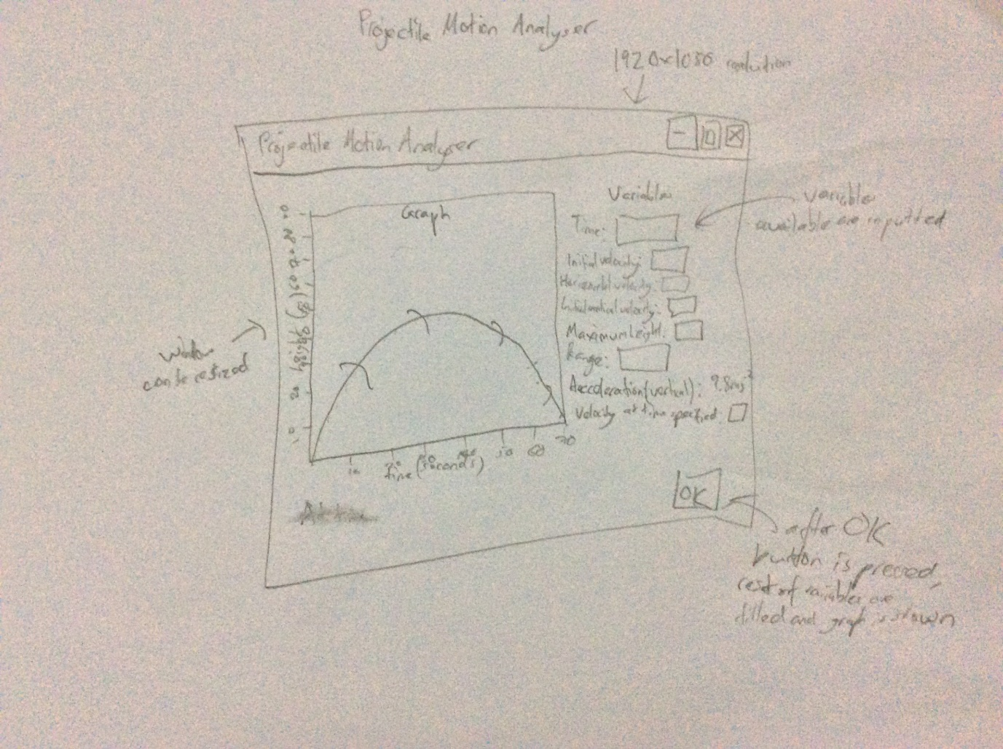

## Feedback for Projectile Motion Analyser before implementation

* Instead of drawing graph using lines and dots to create a curve, Excel can be used to create a curve for the graph.

## Data Structures

No data will be stored permanently by the program, for privacy reasons. Arrays will only be used by the graphing function of the program, as the times and heights of each interval of the projectile motion are required and so arrays must be used.

## Files that are used by the program

1. Projectile_Motion.exe – the application itself. This is required to run the program
2. Required_Excel_File.xlsx – a required Microsoft Excel file. This is used to create the graph.

Project Files: (These are not required to run the program. Visual Basic 6 combines these files into an executable.)

1. Projectile_Motion.frm – the main form. Only 1 form was required to create the program.
2. Projectile_Motion.vbp – the project file.
3. Projectile_Motion.vbw – configuration file created by Visual Basic 6.

# Implementation

## Methods of Conversion

Direct cut-over will be used as the method of installation for the Projectile Motion Analyser. As users will still need to use the old system as well as the new program, as HSC problems must be solved by hand, direct cut-over can be used to allow users to easily start using the Projectile Motion Analyser.

## Tools Used

During implementation, GitHub was used as backup of the program and to record changes to the program. This is available at <https://github.com/spider93287/SDD-Project>

The commit log is included in the project folder under “Commit-log.txt”

## User Documentation

## How to use Projectile Motion Analyser:

Step 1: Double click Projectile_Motion.exe

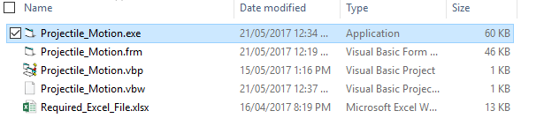

Step 2: Choose Initial velocity or Range and enter the corresponding variable, then click OK.

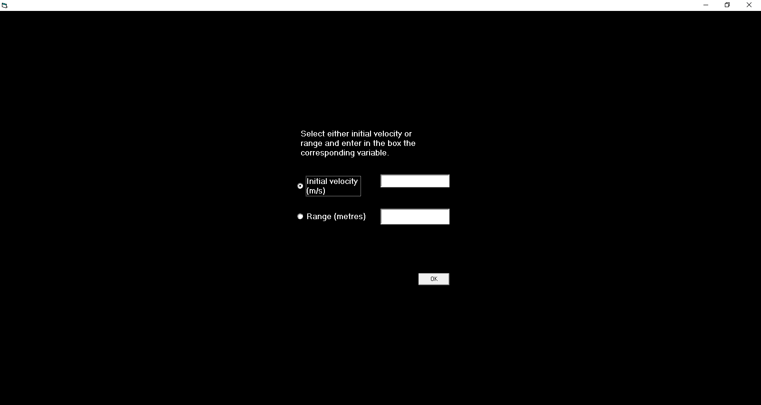

Step 3: Select Angle, Time (or Maximum Height if it is an option) and enter the corresponding variable, then click OK.

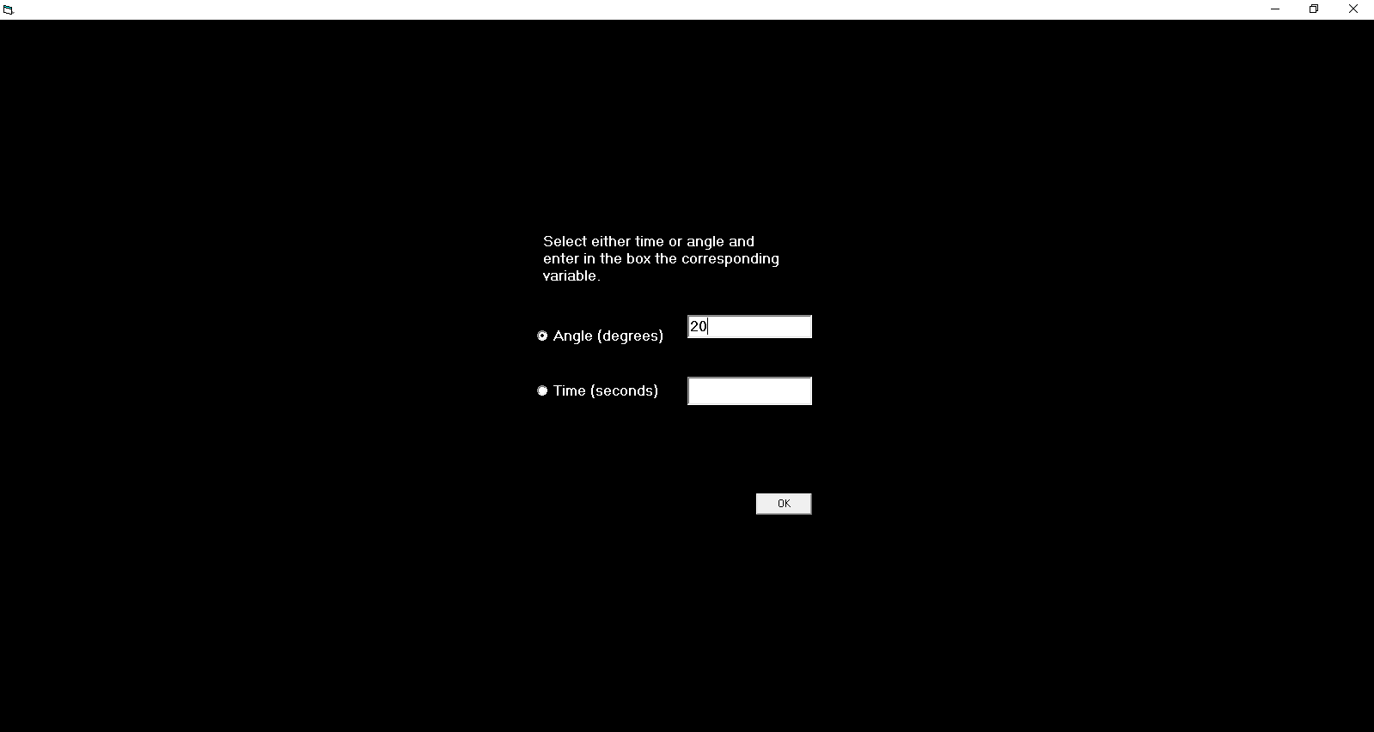

Step 4: Enter the corresponding variable, then click OK.

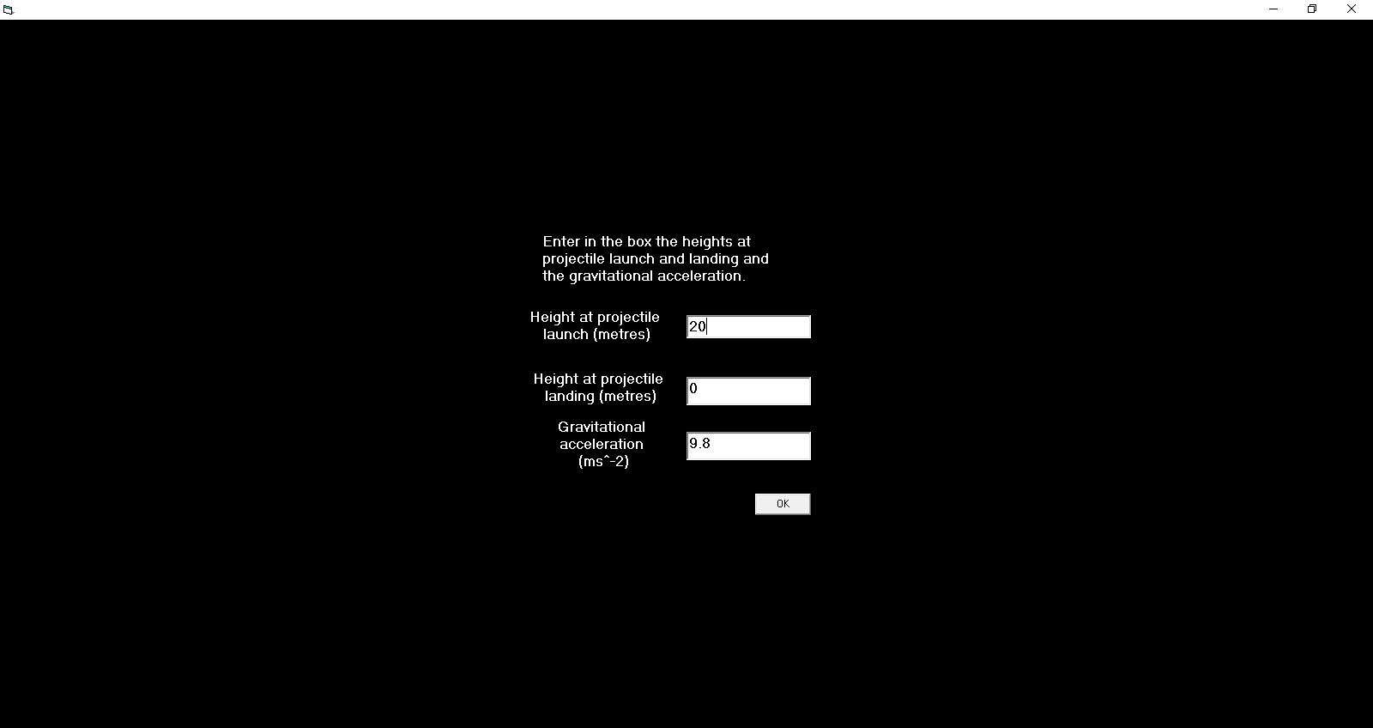

Step 5: Wait for the program to finish loading

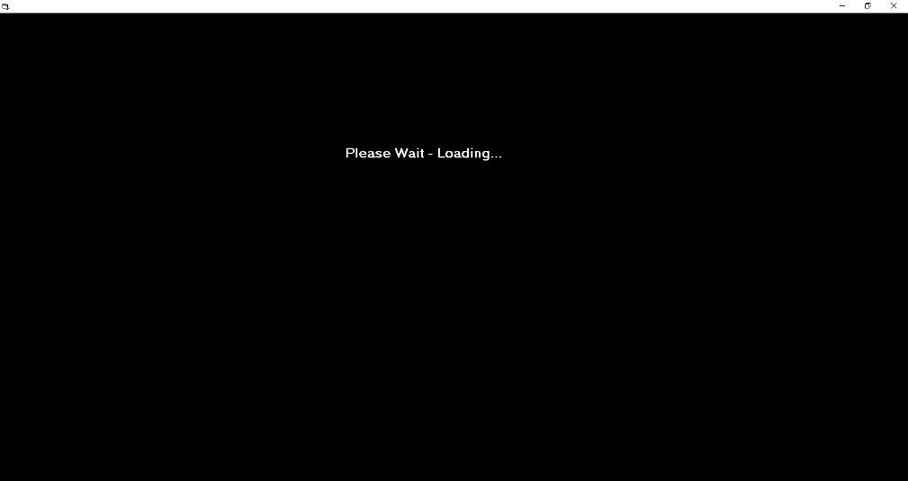

Step 6: The program will load a graph and show all the other variables for the projectile motion.

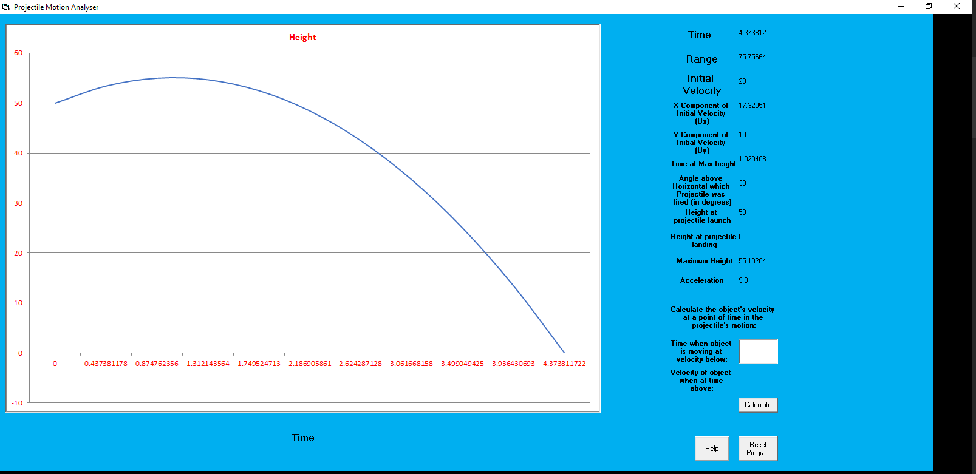

Step 7: You can now calculate the velocity of the projectile at any point in the graph. Enter the point of time in the box here. Then click the Calculate button.

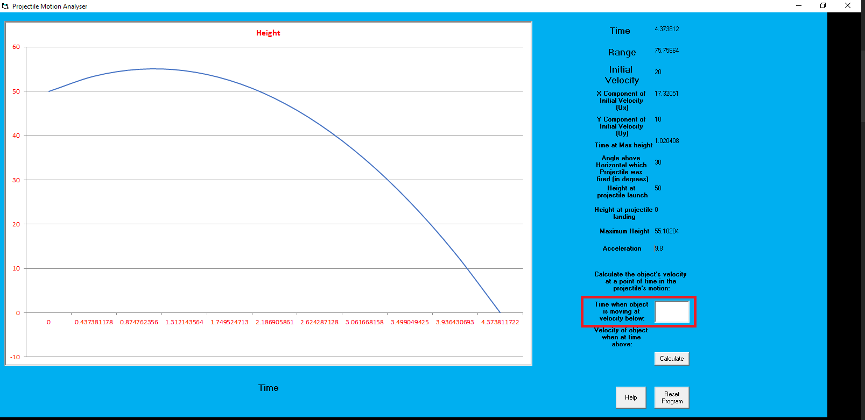

Step 8: The program will show this velocity below.

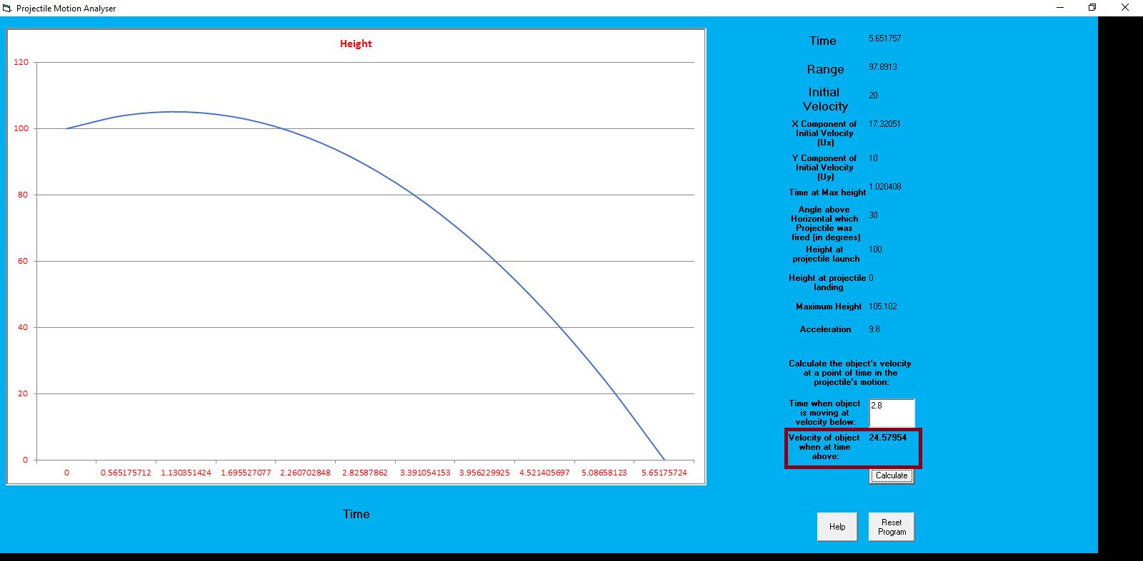

Step 9: If you would like to reset the program and enter another variable, click “Reset Program”

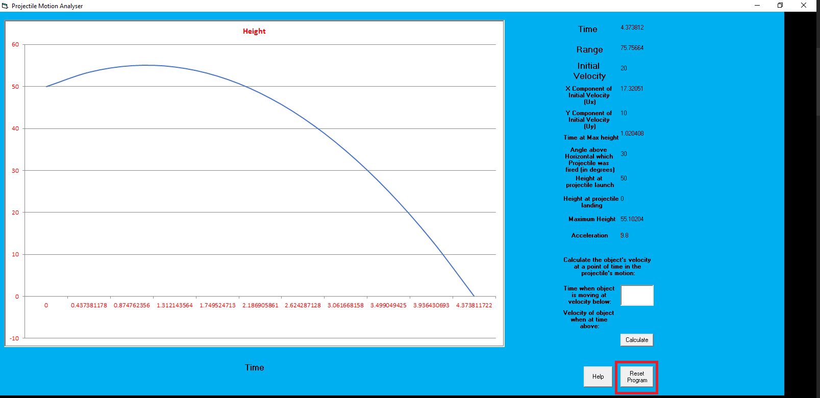

## Feedback

* Previously in the graph, blue lines were shown and an error would be given if the acceleration was made equal to zero. This was given as feedback to the program, and these errors were fixed.
* Previously the textboxes used that outputted variables were user editable. This confused users and some users thought that the program could be reset with new variables by editing these boxes and clicking “Calculate”, which was meant for calculating the variable at any point in the projectile’s motion. These textboxes were edited so they matched the colour of the background and were no longer user editable.
* The program also previously accepted negative numbers. Feedback was received where the program should be edited so negative numbers will not be accepted.
* The program had a confusing UI previously, which was given as feedback to the program. This was resolved by completely revamping the UI so it looked more appealing to the user.
* The program, in the input screens, would not click OK when the key “ENTER” was pressed. One user complained that this is an issue, as most users will instinctively press ENTER instead of clicking OK with a mouse. A function was implemented so the program clicks OK when ENTER is pressed.
* One bug that was reported was that the program continued to run as a process in Windows Task Manager. This bug has not reappeared since, and the cause of the bug is unknown. The program has been scanned by multiple antivirus scanners to ensure that the program does not contain a virus. This may have been caused by Visual Basic 6 itself, and the program’s code most likely did not cause this bug.
* One user reported that the colour scheme made the program look less appealing.
* One user gave feedback that my program should accept irrational numbers and powers.
* One user found over 10 bugs and submitted them on GitHub. Major bugs were found including Excel not closing after the program had been closed, and one of the 5 algorithms not considering the ending height.

One user created a 1000 word report for feedback for my program.

Name: Projectile Motion Analyser

Version: As of 5/6/2017

Date: 05/06/2017

Reviewer: Tanson Wang

I was unable to run the actual program due to differences in program. This is most likely due to the fact that the Microsoft Excel version I was using differed from that of the original programmer, I utilised Excel 2007. I will mainly talking about the aesthetics of the program before the generation of the graph instead.

There was a noticeable lack of a starting screen or title screen on the program which did not leave the most comfortable impression on start up. Due to most users tending to be used to having a title screen this was not the most effective method of starting the program.

The text box containing the text which was presented upon opening Projectile Motion Analyser contained white text upon a black background which made the words highly visible to the user. However, the black background was a bit intense and was, in my opinion not the most favourable choice for a title page.

It was noted that the program did not response in a favourable manner when the screen was resized despite the ability to do so. The screen did not shift or scale when the page was reduced in size hence causing some of the text to be clipped out. Furthermore there was a clear lack of scroll bar if the user did in fact intend to readjust the screen.

The textbox was not correctly centred in the page but rather was slightly to the right of the screen for no apparent reason. It should also be noted that the text was clipped at the end of the sentence near the edge of the textbox. It is unknown whether this is due to a difference in font. These two problems are recurring and have been note throughout every option screen.

Regarding the options and variable input. The inputs could correctly accept only numbers in base ten and did not fail upon placing impossible numbers. Whether the calculation is correct is unknown due to Projectile Motion Analyser not working on my computer. The program was also effective in providing only the choice to choose from options that did not conflict and hence was very effective in that sense.

One of the largest flaws in Projectile Motion Analyser was that there was on option to return to the previous input screen. In most cases users will mistakenly enter information and hence will wish to re-enter the correct values without having to go through the entire process more than once hence having a back button would significantly increase the quality of life for the user.

The access to the help section was poorly done at best. The requirement for the user to access and external website through a URL was highly uncomfortable. To make matters worse the URL needed to be manually typed in due to a lack of the ability to highlight the text. This was further aggravated when resizing caused the loss of the required URL. Also, contrary to the dialog box there was no shortcut link provided within the package containing the test demo.

The help section is at a medium level at this point in time. The help section was one extended page with a lack of a contents page or pages as available on this domain hence the user is required to scroll through the entire page to find the information which they sought when coming to this page. The step by step process was well done with all of the images provided to help guide the user through the process. However rather than include that in the FAQ it is suggested that it is place in a standalone page due to it being part of a how to use rather than a frequently asked question. The frequently asked questions seem to have answered most question that may be asked without any particularly strange circumstances. It should be noted that, similar to the program itself, the page struggles to deal with resizing the screen as the text did not change in size. The ability for people to leave complaints or bug notices is one of the most favourable features of this help section and is a massive positive for this program.

From observations of help section I shall draw some conclusions about the program, considering that it was updated five days prior, 31/05/2017, it should be relatively accurate. The choice of colour for the background was frankly, absolutely horrifying. A neon green on a pitch black background is disagreeable in all circumstances and even worst it does not cover all of the black background. The choice of red text on the white graph was questionable and when considering use by the colour blind it may be slightly unfavourable. The use of a blue line to designate the projectile was fine. The x-axis was highly unpleasant to observe due to the excessive number of digits. Instead it is suggested that the numbers be rounded to perhaps 3 significant figures.

The layout of the results is good and efficient for the user. It has provided, from as much as I can see from the pixelated screenshot, all of the crucial information as expected from Projectile Motion Analyser. The black text within a white textbox is good choice. The ability to choose a time and gain the position of the projectile was a nice touch that truly managed to improve the program. The reset button really should have a back button next to it though.

Overall, the aesthetic state of the program is quite poor. The functioning of available inputs has been satisfactory.

* **A survey was set up so users could give feedback on the program. These responses are in a folder called “Survey Responses” in the project folder.**

# Evaluation

## Testing

1. Projectile Problems from Surfing Space Book:

Gives correct data for every problem.

1. Projectile Problems from HSC

**EXCEL HSC Space Section: Question 3**

The program returns “Please enter more variables” due to it finding the angle is 0. However, the initial angle is actually 0 in the question.

Bug has been fixed, now program will detect whether a box is blank instead of whether it contains a 0.

The program gives the correct answer to this question.

**2008 HSC Question 3**

The program gives the correct answer to this question.

**2010 HSC Question 22**

The program supports a default acceleration value of 9.8 ms-2 for gravity, as this is the acceleration value of gravity on Earth. However, this question uses the acceleration value on the Moon, which is 1.6ms-2, and so currently the program cannot solve this question.

An acceleration option has been added, with the default value set at 9.8, however the user can change this value.

Therefore, the program can now solve this question and gives the correct answer to this question.

**2011 HSC Question 15**

The program gives the correct answer to this question.

**2012 HSC Question 27**

The program DOES NOT give the correct answer to this question. In the program’s code, “300” was written instead of the variable “range”, making the algorithm give a wrong answer. This was fixed, and now the program gives the correct answer to this question.

**GHS Trials Q3 2006**

The program gives the correct answer to this question.

**Independent Trials Q16 2006**

The program gives the correct answer to this question.

**NEAP Trials Q16 2006**

The program gives the correct answer to this question.

**Catholic School Trials Q17 2006**

The program gives the correct angle but in radians, not in degrees. This bug was fixed, and the program now gives the correct answer.

## Requirements

1. The program is to run on Microsoft Windows machines and must fit a 1920x1080 resolution as this is the resolution that school computer displays have.

This requirement is met, as the program was tested on school computers and does work on a 1920x1080 resolution.

1. The program must not crash when the program is put in use

The program does not crash when the program is put in use, and so this requirement is also met.

1. The program must run on a computer with 4GB RAM.

The program runs perfectly fine with no performance issues on a computer with 4GB RAM.

1. The program must be able to visualize the projectile motion specified by the user and output variables that can be calculated from the information inputted into the program.

The program accurately calculates any projectile motion specified by the user.

1. If the program cannot calculate any information from the data given, the program will output an error displaying that the information given is not sufficient.

The program includes many error checks to ensure the input given is sufficient.

1. The user should be able to use the program again after the user has inputted information for a projectile motion problem without having to reopen the program.

A “Reset Program” function was added to ensure the program can be used again without the user having to reopen the program.

1. The program must give an error when non-numeric characters have been entered.

The program includes error checking to ensure no non-numeric characters are entered which may cause the program to crash.

## Testing on school computers and other computers

* The program was tested on school network computers. The program does work fine, but the graph fails to load. This is currently not fixed yet.
* The program was also tested on other computers that ran Windows 7 and Windows 10. Due to Visual Basic 6 limitations, a DLL file had to be placed in C:\Windows\syswow64 in order for the program to run, but otherwise the program ran fine on all these computers
* Other users tested the program, and could operate the program quite easily. Some UI elements were changed due to confusion in using the program, but currently the program can be used by people with less experience with computers.

## Documentation of the testing process

Test requirements:

* The program gives the correct answers to any projectile motion question, especially HSC questions.
* The program is easy to use and no confusion occurs when other users use the program.
* The program does not crash while a user is using it.
* The program does not contain any bugs.

Test plan:

* A set of projectile motion questions were set up to test the program. The program gave the correct answers to all questions. The program also answered every single HSC question correctly.
* The program was then given to other users to test. More bugs were found this way, and all were fixed accordingly.
* A survey was set up so other users could give feedback on how the program could be improved. These survey responses are in a folder labelled “Survey Responses” in the project folder.

Test data and expected results:

* The test data listed in the “Plan and Design” section above was used to test the program. The inputs were variables given by the projectile motion problems, and the outputs were all other projectile motion variables.
* The actual results did match the expected results.

Recommendations

* The program should now continue to be evaluated until the due date, to ensure no bugs exist in the program.

# Maintenance

## Changes in Source Code and Designs

The program was edited with a new UI to make it easier to use. The program now gives 2 options, initial velocity and range, and gives more options after one is selected. The algorithm is selected based on the option the user picks.

Old UI:

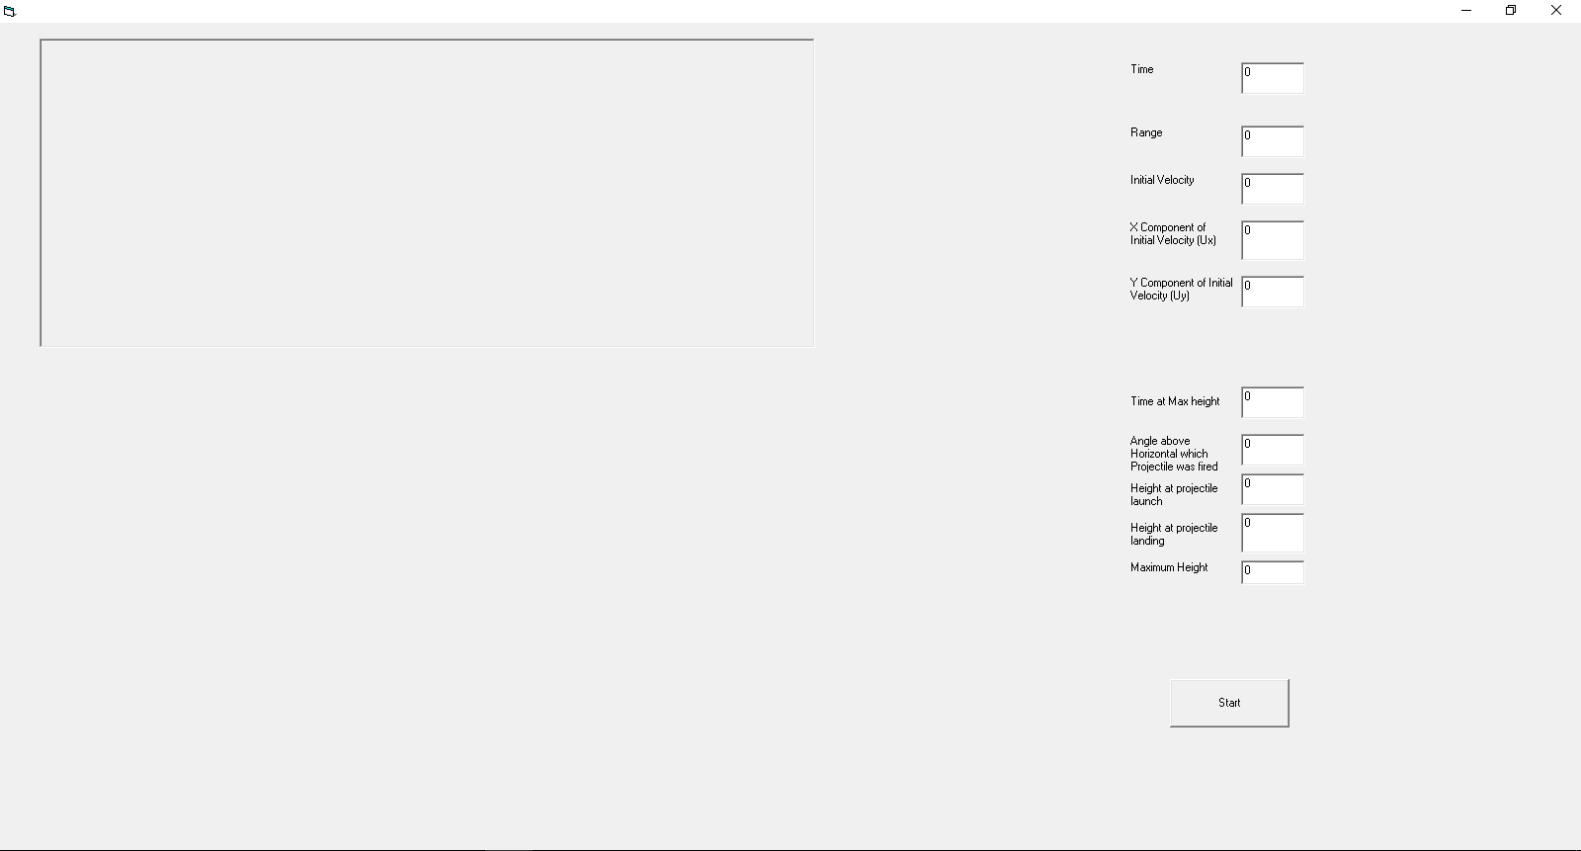

New UI:

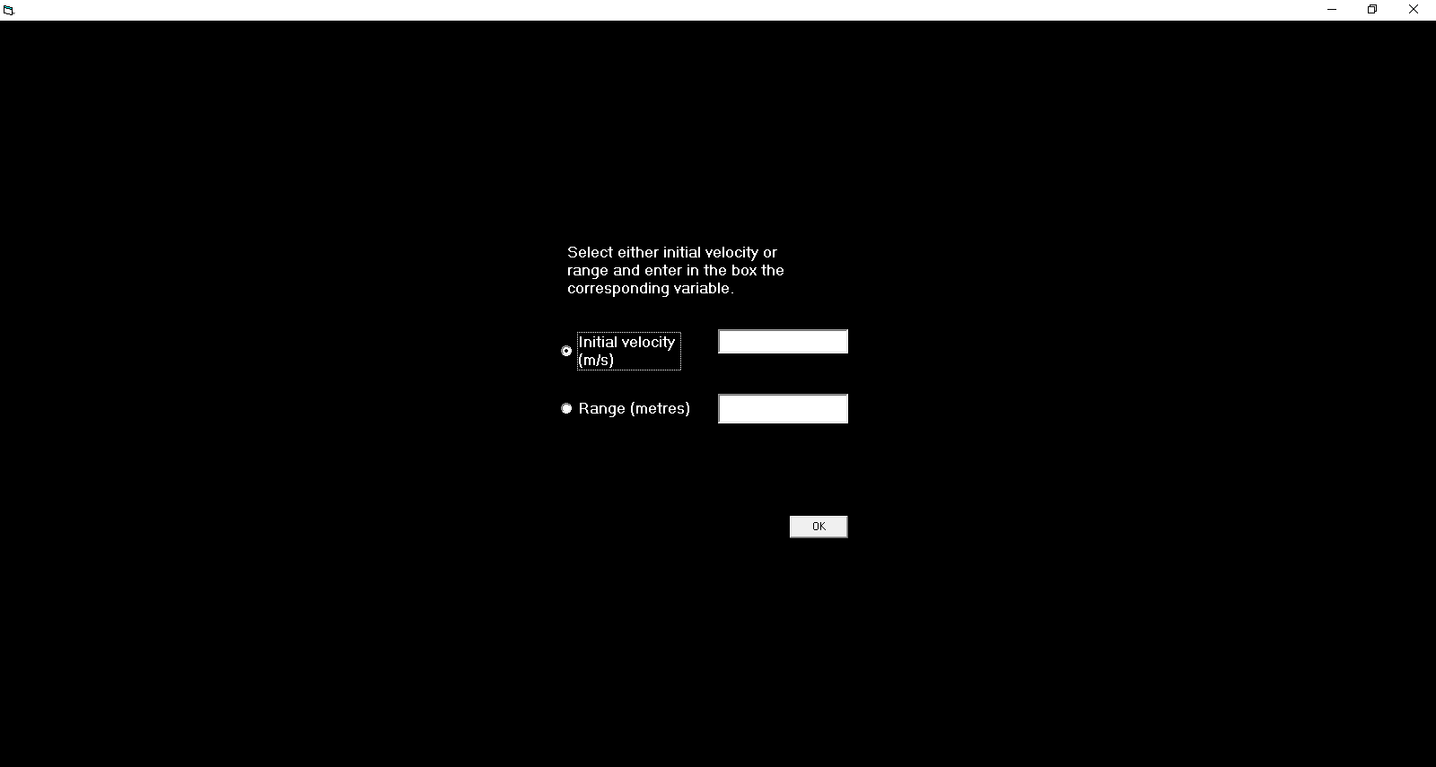

A function to calculate the projectile’s velocity at a time during the projectile’s journey was also added, to allow the program to be able to solve more projectile problems. This function can only be used after the graph has been shown. More error messages were added to ensure that the program does not crash when a user is using it.

## Documentation

Source code documentation has been provided in the source code in the form of comments. Each line of code has been explained.

GitHub was used as a version control system. Anytime changes to the code or portfolio were made, it was recorded in GitHub and a “commit” was sent to GitHub. This can be viewed at:

<https://github.com/spider93287/SDD-Project>

The list of commits can be viewed in a file in the project folder as well.

Online help was provided in the program. A help button could be clicked, and a message displaying how to view the online help was added. An internet shortcut to the online help has been added.

# Social and Ethical Issues Testing

## Authorship/Copyright

The Department of Education owns this program, and so the program will not be distributed commercially.

## Reliability

The program has been tested thoroughly, on school computers and on other computers, and the program works efficiently on all computers. It can perform all tasks given to it, and gives the correct answers to projectile motion problems given to the program.

## Response to Problems

Most problems that have raised in the program have been fixed, except for those that were found right before the due date, and so time could not permit fixing these problems.

## Malware

The program is virus-free according to VirusTotal.

<https://virustotal.com/en/file/318b03f9757846e368f943184f115e3050240075feb0571b09e8baf5c737f71f/analysis/1495330428/>

## Plagiarism

The program has not copied any code from any other sources.

## Marketing Brochure



### End User Agreement

|  |
| --- |
| MIT License |
|  |  |
|  | Copyright (c) 2017 spider93287 |
|  |  |
|  | Permission is hereby granted, free of charge, to any person obtaining a copy |
|  | of this software and associated documentation files (the "Software"), to deal |
|  | in the Software without restriction, including without limitation the rights |
|  | to use, copy, modify, merge, publish, distribute, sublicense, and/or sell |
|  | copies of the Software, and to permit persons to whom the Software is |
|  | furnished to do so, subject to the following conditions: |
|  |  |
|  | The above copyright notice and this permission notice shall be included in all |
|  | copies or substantial portions of the Software. |
|  |  |
|  | THE SOFTWARE IS PROVIDED "AS IS", WITHOUT WARRANTY OF ANY KIND, EXPRESS OR |
|  | IMPLIED, INCLUDING BUT NOT LIMITED TO THE WARRANTIES OF MERCHANTABILITY, |
|  | FITNESS FOR A PARTICULAR PURPOSE AND NONINFRINGEMENT. IN NO EVENT SHALL THE |
|  | AUTHORS OR COPYRIGHT HOLDERS BE LIABLE FOR ANY CLAIM, DAMAGES OR OTHER |
|  | LIABILITY, WHETHER IN AN ACTION OF CONTRACT, TORT OR OTHERWISE, ARISING FROM, |
|  | OUT OF OR IN CONNECTION WITH THE SOFTWARE OR THE USE OR OTHER DEALINGS IN THE |
|  | SOFTWARE. |

# Bibliography

1. <http://www.xtremevbtalk.com/excel/323874-thisworkbook-close-falses-causes-excel-2007-crash.html> - Date Accessed: 11/06/2017
2. <https://superuser.com/questions/519841/getting-msstdfmt-dll-missing-when-starting-visual-basic-6-application> - Date Accessed: 4/06/2017
3. <https://stackoverflow.com/questions/4530741/visual-basic-open-url-with-default-browser> - Date Accessed: 4/06/2017
4. <https://superuser.com/questions/519841/getting-msstdfmt-dll-missing-when-starting-visual-basic-6-application> - Date Accessed: 31/05/2017
5. <https://bytes.com/topic/visual-basic-net/answers/954118-execute-button-click-event-enter-keypress> - Date Accessed: 25/05/2017
6. <https://superuser.com/questions/519841/getting-msstdfmt-dll-missing-when-starting-visual-basic-6-application> - Date Accessed: 21/05/2017
7. <https://msdn.microsoft.com/en-us/library/8067cy78(v=vs.90).aspx> – Date Accessed: 29/04/2017
8. <https://msdn.microsoft.com/en-us/library/06s37a7f.aspx> - Date Accessed: 29/04/2017
9. <http://stackoverflow.com/questions/14876677/enable-and-disable-textbox-with-a-checkbox-in-visual-basic> - Date Accessed: 29/04/2017
10. <https://msdn.microsoft.com/en-us/library/256tssz7(v=vs.90).aspx> – Date Accessed: 29/04/2017
11. <https://bytes.com/topic/visual-basic-net/answers/443797-how-maximize-form-open> - Date Accessed: 29/04/2017
12. <http://www.vb6.us/tutorials/understanding-arrays> - Date Accessed: 16/04/2017
13. <http://www.dreamincode.net/forums/topic/174451-using-excel-with-visual-basic-6/> - Date Accessed: 16/04/2017
14. <https://msdn.microsoft.com/en-us/library/ddck1z30.aspx> - Date Accessed: 15/04/2017
15. <https://msdn.microsoft.com/en-us/library/w3t84e33.aspx> - Date Accessed: 12/04/2017
16. <https://msdn.microsoft.com/en-us/library/thc0a116.aspx> - Date Accessed: 12/04/2017
17. <http://www.tek-tips.com/viewthread.cfm?qid=656969> – Date Accessed: 10/04/2017
18. <https://msdn.microsoft.com/en-us/library/xay7978z.aspx> - Date Accessed: 10/04/2017
19. <https://msdn.microsoft.com/en-us/library/s2dy91zy.aspx> - Date Accessed: 10/04/2017
20. <https://msdn.microsoft.com/en-us/library/zh100ckf.aspx> - Date Accessed: 10/04/2017
21. <https://msdn.microsoft.com/en-us/library/6xxtk8kx.aspx> - Date Accessed: 10/04/2017